Networking (socket module)

Python is general purpose programming language. It allows developing different types of applications.
Python allows to develop networking enabled applications or networking applications.

What is networking?
Networking is logical or physical link between two or more devices.
Advantage of networking is sharing resources (hardware or software) and communication.

For developing networking application python provided a standard module (socket)

Basics of networking

What is ip-address?
In networking every device is identified with unique number called ip-address.

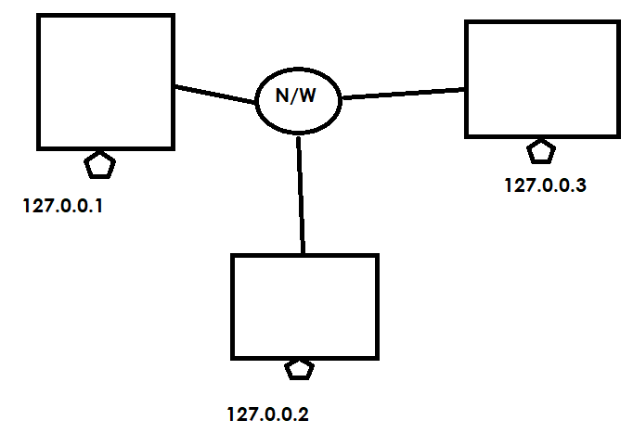

Networking application is having 2 programs
- Client
- Server

Client is a program which send/input data to server
Server is a program which receives input given by client, processes it and generates output (response).

What is protocol?
A protocol defines set of rules and regulations to exchange data between two applications.

- HTTP (Hyper Text Transfer Protocol)
- FTP (File Transfer Protocol)
- SMTP (Simple Object Mail transfer protocol)
- POP (Post Office Protocol)
- TCP (transmission control protocol)

What is portno?
Every server program is identified with one unique number called portno. Portno is integer value which range from 1 to 65535

What is a socket?
A socket is an end point communication between 2 programs
- Client
- Server

Client or server programs are implementation of sockets.

Network communication can be,
- Connection oriented (TCP 🡪 Transmission Control Protocol)
- Connection less (UDP 🡪 User Datagram Protocol)

In connection oriented communication, client program connect to server program. Server program must accept connection of client program.

In connection less communication client send data to server using packets (data+address).

Socket module provides predefined sockets for developing networking applications.

class socket.socket(family=AF_INET, type=SOCK_STREAM)
create socket object for communicating with client or server

type of socket
- SOCK_STREAM 🡪 TCP implementation or connection oriented
- SOCK_DGRAM 🡪 UDP implementation or connection less

Methods
socket.accept()
Accept a connection. The socket must be bound to an address and listening for connections.

socket.bind(address)
Bind the socket to address. The socket must not already be bound.

socket.close()
Mark the socket closed.

socket.connect(address)
Connect to a remote socket at address

socket.recv(bufsize[, flags])
Receive data from the socket. The return value is a bytes object representing the data received.

socket.send(bytes[, flags])
Send data to the socket. The socket must be connected to a remote socket.

Srever1.py
# Server Program
import socket

s=socket.socket()
s.bind(("127.0.0.1",60))
s.listen(5)
print("Server is running....")
s.accept()
print("Server Accepted connection of client")
s.close()

client1.py
#Client Program
import socket

s=socket.socket()
s.connect(("127.0.0.1",60))
s.close()

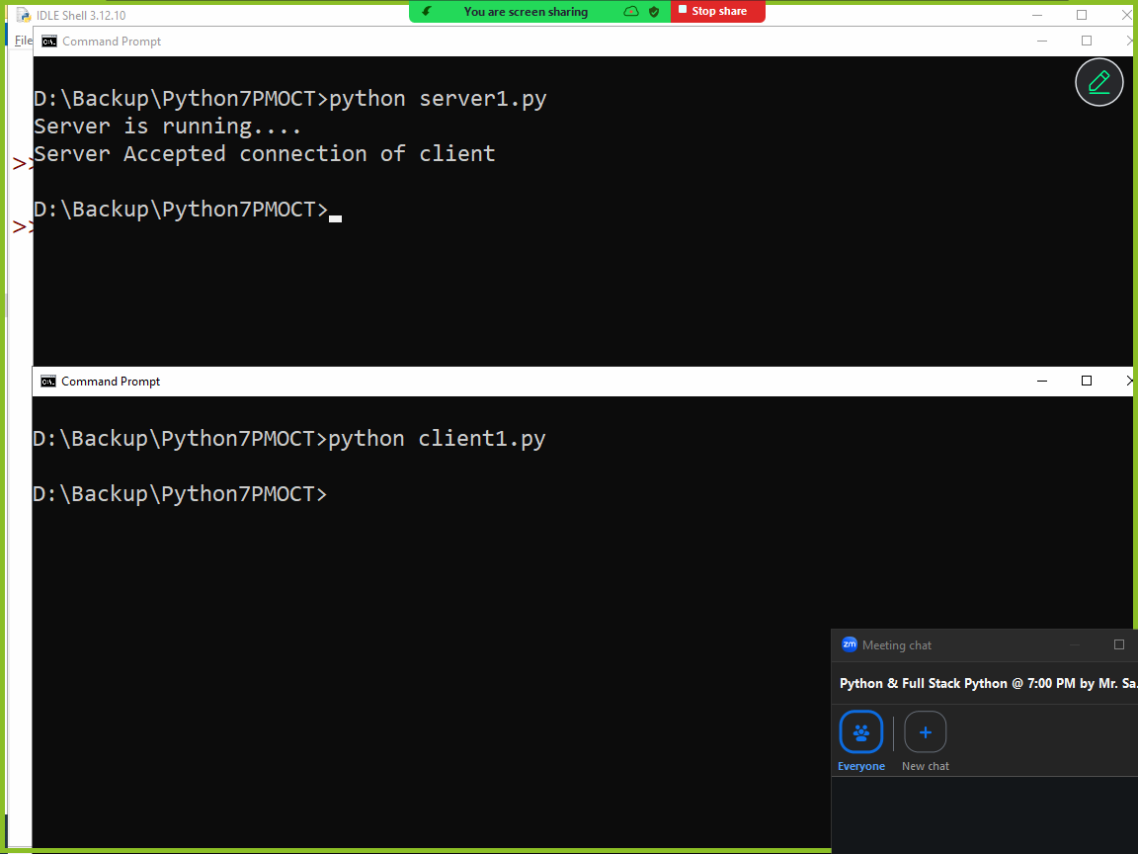

Server1.py
# Server Program
import socket

s=socket.socket()
s.bind(("127.0.0.1",60))
s.listen(5)
print("Server is running....")
t=s.accept()
print("Server Accepted connection of client")
c=t[0]
b=c.recv(1024)
msg=b.decode()
print(msg)
msg="Hello Client"
b=msg.encode()
c.send(b)
s.close()

Client1.py
#Client Program
import socket

s=socket.socket()
s.connect(("127.0.0.1",60))
message="Hello Server"
b=message.encode()
s.send(b)
b=s.recv(1024)
msg=b.decode()
print(msg)
s.close()
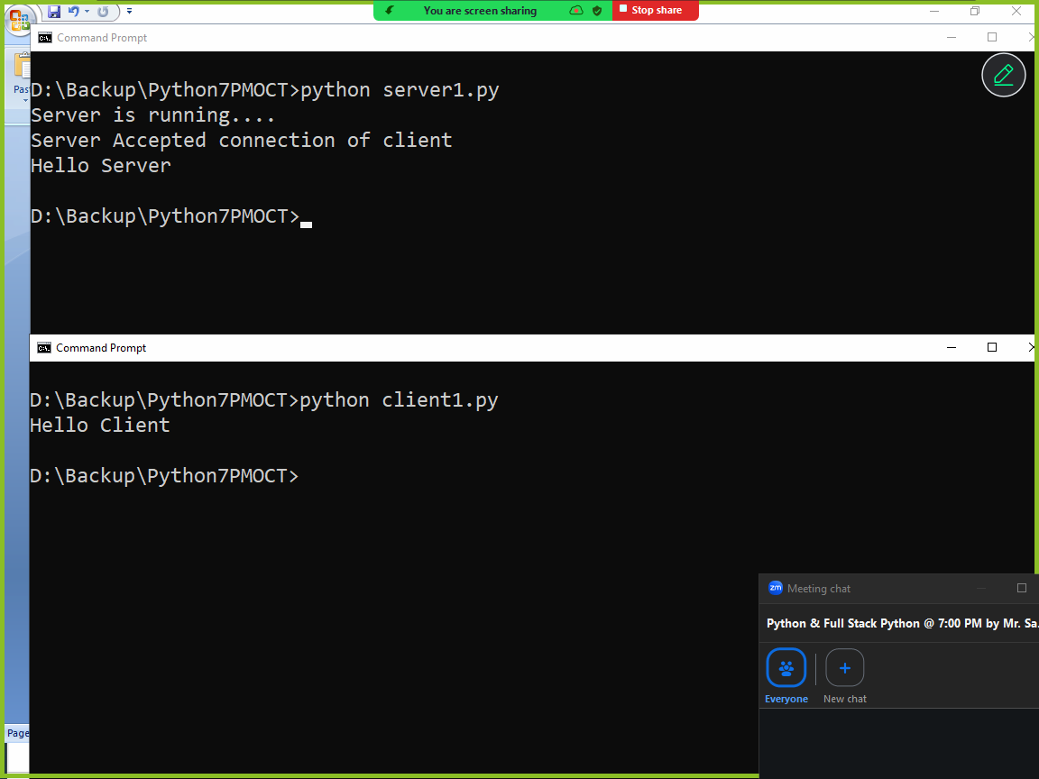

Resultserver.py
# Result Processing Server
import socket
marks={1:["naresh",50,60],
2:["suresh",70,80],
3:["ramesh",90,70],
4:["kishore",40,30],
5:["rajesh",20,90]}

s=socket.socket()
s.bind(("localhost",60))
s.listen(5)
print("Server is Running...")

while True:
t=s.accept()
c=t[0]
rollno=c.recv(1024)
rollno=int(rollno.decode())
if rollno in marks:
m=marks[rollno]
name,s1,s2=m
if s1<40 or s2<40:
result="Fail"
else:
result="Pass"

output=f''''Rollno:{rollno}
StudentName:{name}
Subject1Marks:{s1}
Subject2Marks:{s2}
Resut:{result}
Total:{s1+s2}'''
b=output.encode()
c.send(b)
else:
msg="Invalid Rollno"
b=msg.encode()
c.send(b)

studentclient.py
# student client program

import socket

s=socket.socket()
s.connect(("localhost",60))
rollno=input("Rollno :")
b=rollno.encode()
s.send(b)
b=s.recv(1024)
output=b.decode()
print(output)

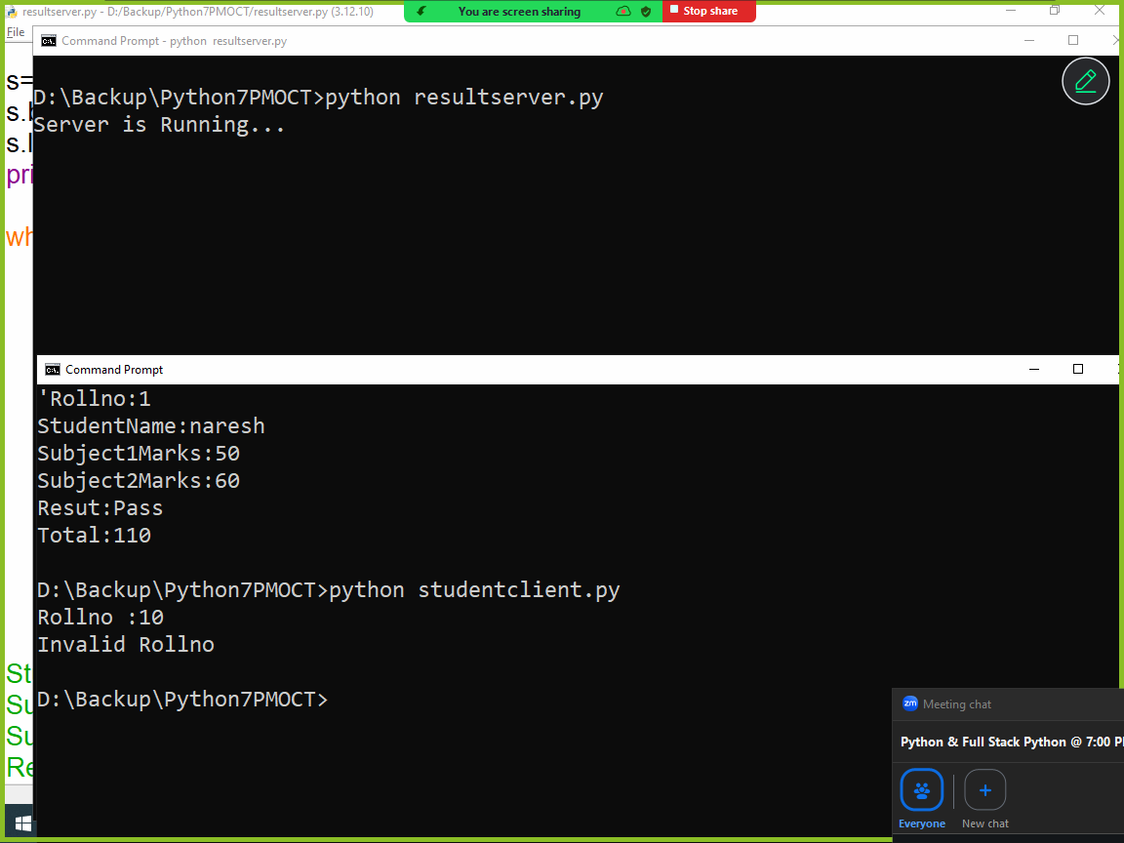

datetime module (OR) working with date and time data types

datetime module is a standard module which comes with python software. This module provides the following classes or data types to work with date and time

- date
- time
- datetime
- timedelta

date datatype
This data type or class represents date object.
Date object is created using 3 attributes
- day
- month
- year
date object is an immutable object, which cannot modified after creation.

Syntax: date(year,month,day)

Day value must be based numbers of day in given month.
Month value must >=1 and <=12
Year value must be 9999

If given values are not with given range it generates ValueError.

Example:
import datetime

d=datetime.date(2026,2,10)
print(d)
print(d.day)
print(d.month)
print(d.year)

Output
2026-02-10
10
2
2026

Datetime.date.today()

today() is static method date class, which returns current date or system date.

import datetime

d=datetime.date.today()
print(d)

time class or data type
This class or data type is used for represent time, which is independent of any particular day

Datetime.time(hour=0,minuts=0,seconds=0,millseconds=0)

Time object is immutable, after creating time changes cannot done

Example
import datetime

t1=datetime.time()
print(t1)
print(t1.hour)
print(t1.minute)
print(t1.second)

Output
00:00:00
0
0
0

datetime class or datatype
datetime class object represents date and time
A single object represents two objects (date and time)

Syntax: datetime.datetime(year,month,day,hour=0,second=0,minute=0)

>>> import datetime
>>> dt=datetime.datetime(2026,2,10)
>>> print(dt)
2026-02-10 00:00:00
>>> dt1=datetime.datetime(2026,2,10,8,40,57)
>>> print(dt1)
2026-02-10 08:40:57
>>> dt2=datetime.datetime.today()
>>> print(dt2)
2026-02-10 20:42:24.801424
>>> d1=dt2.date()
>>> t1=dt2.time()
>>> print(d1)
2026-02-10
>>> print(t1)
20:42:24.801424

timedelta class
timedelta represents the difference between two dates and times

>>> timedelta(days,weeks)

>>> d1=datetime.date.today()
>>> print(d1)
2026-02-10
>>> days=datetime.timedelta(days=5)
>>> d1=d1+days
>>> print(d1)
2026-02-15
>>> d1=d1-days
>>> print(d1)
2026-02-10
>>> m=datetime.timedelta(weeks=4)
>>> d1=d1+m
>>> print(m)
28 days, 0:00:00
>>> print(d1)
2026-03-10
>>> d1=d1-m
>>> print(d1)
2026-02-10
>>> y=datetime.timedelta(days=365)
>>> d1=d1+y
>>> print(d1)
2027-02-10
>>> d1=d1-y
>>> print(d1)
2026-02-10

Formatting date and time
Formatting date and time done using strftime() method of datetime

Directive | Meaning | Example
%a | Weekday as locale’s abbreviated name. | Sun, Mon, …, Sat (en_US);  So, Mo, …, Sa (de_DE)
%A | Weekday as locale’s full name. | Sunday, Monday, …, Saturday (en_US);  Sonntag, Montag, …, Samstag (de_DE)
%w | Weekday as a decimal number, where 0 is Sunday and 6 is Saturday. | 0, 1, …, 6
%d | Day of the month as a zero-padded decimal number. | 01, 02, …, 31
%b | Month as locale’s abbreviated name. | Jan, Feb, …, Dec (en_US);  Jan, Feb, …, Dez (de_DE)
%B | Month as locale’s full name. | January, February, …, December (en_US);  Januar, Februar, …, Dezember (de_DE)
%m | Month as a zero-padded decimal number. | 01, 02, …, 12
%y | Year without century as a zero-padded decimal number. | 00, 01, …, 99
%Y | Year with century as a decimal number. | 0001, 0002, …, 2013, 2014, …, 9998, 9999
%H | Hour (24-hour clock) as a zero-padded decimal number. | 00, 01, …, 23
%I | Hour (12-hour clock) as a zero-padded decimal number. | 01, 02, …, 12
%p | Locale’s equivalent of either AM or PM. | AM, PM (en_US);  am, pm (de_DE)
%M | Minute as a zero-padded decimal number. | 00, 01, …, 59
%S | Second as a zero-padded decimal number. | 00, 01, …, 59
%f | Microsecond as a decimal number, zero-padded to 6 digits. | 000000, 000001, …, 999999
%z | UTC offset in the form ±HHMM[SS[.ffffff]] (empty string if the object is naive). | (empty), +0000, -0400, +1030, +063415, -030712.345216
%Z | Time zone name (empty string if the object is naive). | (empty), UTC, GMT
%j | Day of the year as a zero-padded decimal number. | 001, 002, …, 366
%U | Week number of the year (Sunday as the first day of the week) as a zero-padded decimal number. All days in a new year preceding the first Sunday are considered to be in week 0. | 00, 01, …, 53
%W | Week number of the year (Monday as the first day of the week) as a zero-padded decimal number. All days in a new year preceding the first Monday are considered to be in week 0. | 00, 01, …, 53
%c | Locale’s appropriate date and time representation. | Tue Aug 16 21:30:00 1988 (en_US);  Di 16 Aug 21:30:00 1988 (de_DE)
%x | Locale’s appropriate date representation. | 08/16/88 (None);  08/16/1988 (en_US);  16.08.1988 (de_DE)
%X | Locale’s appropriate time representation. | 21:30:00 (en_US);  21:30:00 (de_DE)
%% | A literal '%' character. | %

Example:
import datetime

dt=datetime.datetime.today()
print(dt.strftime("%d"))
print(dt.strftime("%a"))
print(dt.strftime("%A"))
print(dt.strftime("%d %A"))
print(dt.strftime("%m"))
print(dt.strftime("%b"))
print(dt.strftime("%B"))
print(dt.strftime("%d %a %B"))
print(dt.strftime("%y"))
print(dt.strftime("%Y"))
print(dt.strftime("%d %B %A %Y"))
print(dt.strftime("%H"))
print(dt.strftime("%M"))
print(dt.strftime("%S"))
print(dt.strftime("%H:%M:%S"))
print(dt.strftime("%I:%M:%S %p"))
print(dt.strftime("%j"))
print(dt.strftime("%U"))
print(dt.strftime("%c"))
print(dt.strftime("%x"))

Output
10
Tue
Tuesday
10 Tuesday
02
Feb
February
10 Tue February
26
2026
10 February Tuesday 2026
20
58
47
20:58:47
08:58:47 PM
041
06
Tue Feb 10 20:58:47 2026
02/10/26

